|  |  |
| --- | --- |
| Opportunities Platform  Description document | Group U  Bachelor of Science in Software Engineering |

|  |  |  |
| --- | --- | --- |
| **Name** | **Registration Number** | **Student number** |
| Kalibbala Johnson | 21/U/08735/EVE | 2100708735 |
| Tusiimirwe Jemily | 21/U/08438/EVE | 2100708438 |
| Mboowa Haulah Namagga | 21/U/16366/EVE | 2100716366 |
| Aine Daniel Mwejune | 21/U/15696/PS | 2100715696 |
| Acan Brenda | 21/U/05295/EVE | 2100705295 |

Table of Contents

1. Introduction 1

1.1. Purpose 1

1.2. Scope 1

1.3. Overview 1

2. System Overview 1

3. System architecture 2

3.1. Architectural design 2

3.2. Decomposition description 2

3.3. Design rationale 3

4. Human interface 3

# Introduction

## Purpose

This document provides a description of the architecture and system design of a platform intended to connect students with internship and job opportunities allowing them to submit resumes and view job listings.

## Scope

On this platform organizations will be able to list internship and job opportunities with the needed qualifications. Students will also be able to view the opportunities listed and apply to any of their interests. This will help students to find the available opportunities and bridge the gap between students and organizations by simplifying the application process.

## Overview

This document is divided into sections that describe various aspects of the project.

* System overview: This section provides a general description of the functionality, context, and design of the project.
* System architecture: This section provides a modular program structure and explains the relationships between the modules to achieve the complete functionality of the system. It also provides a decomposition of the subsystems in the architectural design.
* Data design: This section describes how the major data or system entities are stored, processed, and organized.
* Component design: In this section, we take a closer look at what each component does in a more systematic way using simple algorithms.
* Human interface design: This section describes the functionality of the system from the user’s perspective using screen images.

# System Overview

To use this platform, students and organizations will be required to sign up. For a student to sign up, they will need to enter their full name, a valid email, a password, and username. Organizations will also be required to provide descriptive information about themselves like a website link, a valid email, and a password to sign up.

After signing up companies will be able to list out the various internship and job opportunities on the platform and view resumes submitted to them. Students will then be able to apply for any of the listed opportunities that sends their resume to the organization that listed the opportunity. The company will then be able to view the resumes from different applicants.

An administrator logs in without signing up with the default administrator credentials and views a summary of the system and can perform general management of the system.

# System architecture

## Architectural design

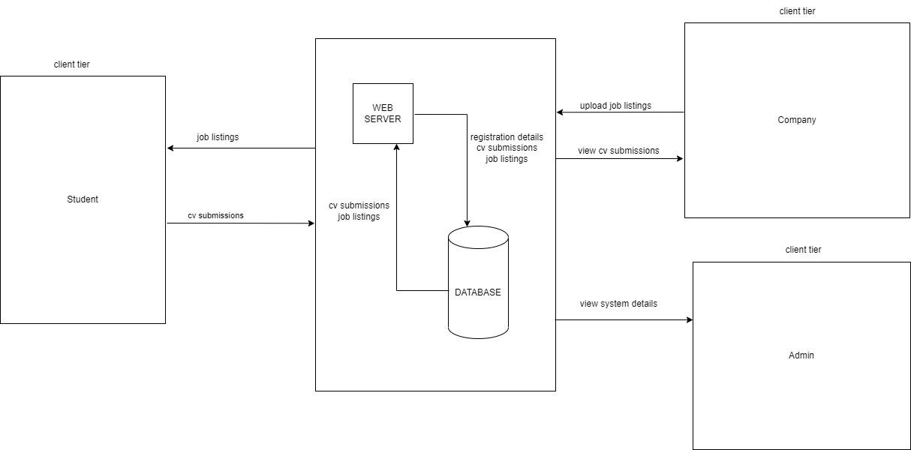

Figure showing overview of the system.

## Decomposition description

* + 1. Data decomposition

The structure of the database is described in the Entity Relationship Diagram below.

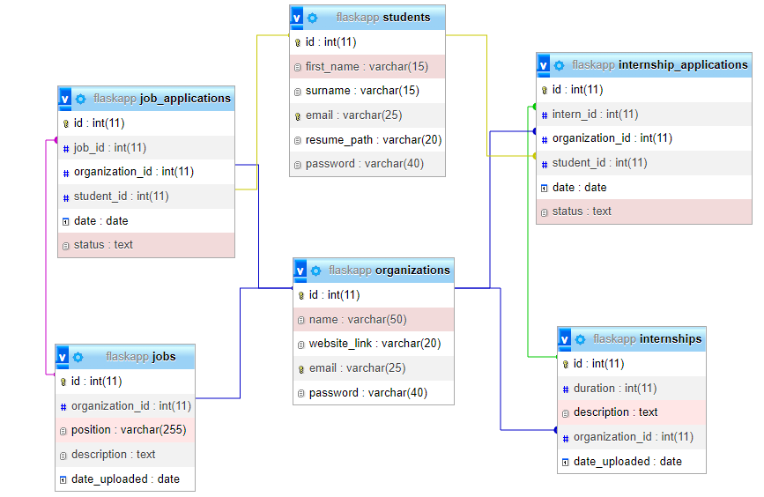

Figure showing Entity Relationship Diagram to represent the database structure.

* + 1. Structural decomposition

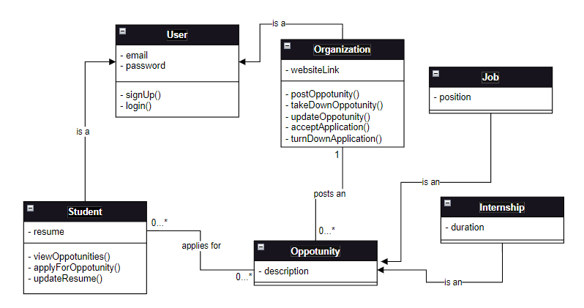

Figure showing Class diagram of the system.

## Design rationale

To avoid many-to-many relationships between the entities student and opportunities, in the database two entities, job_applications and internship_applications are created.

# Human interface

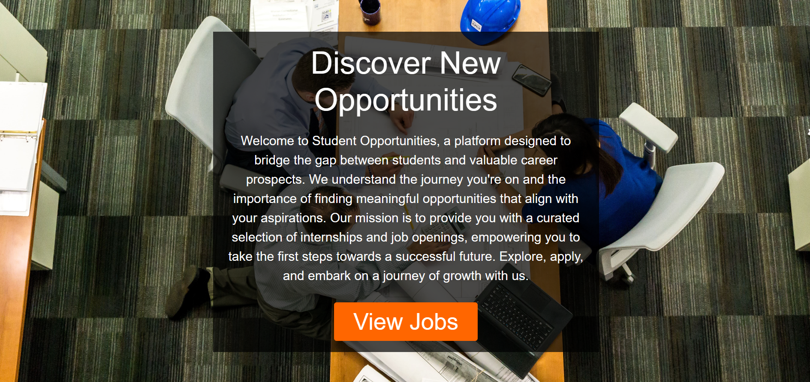

Figure Landing page for the platform.

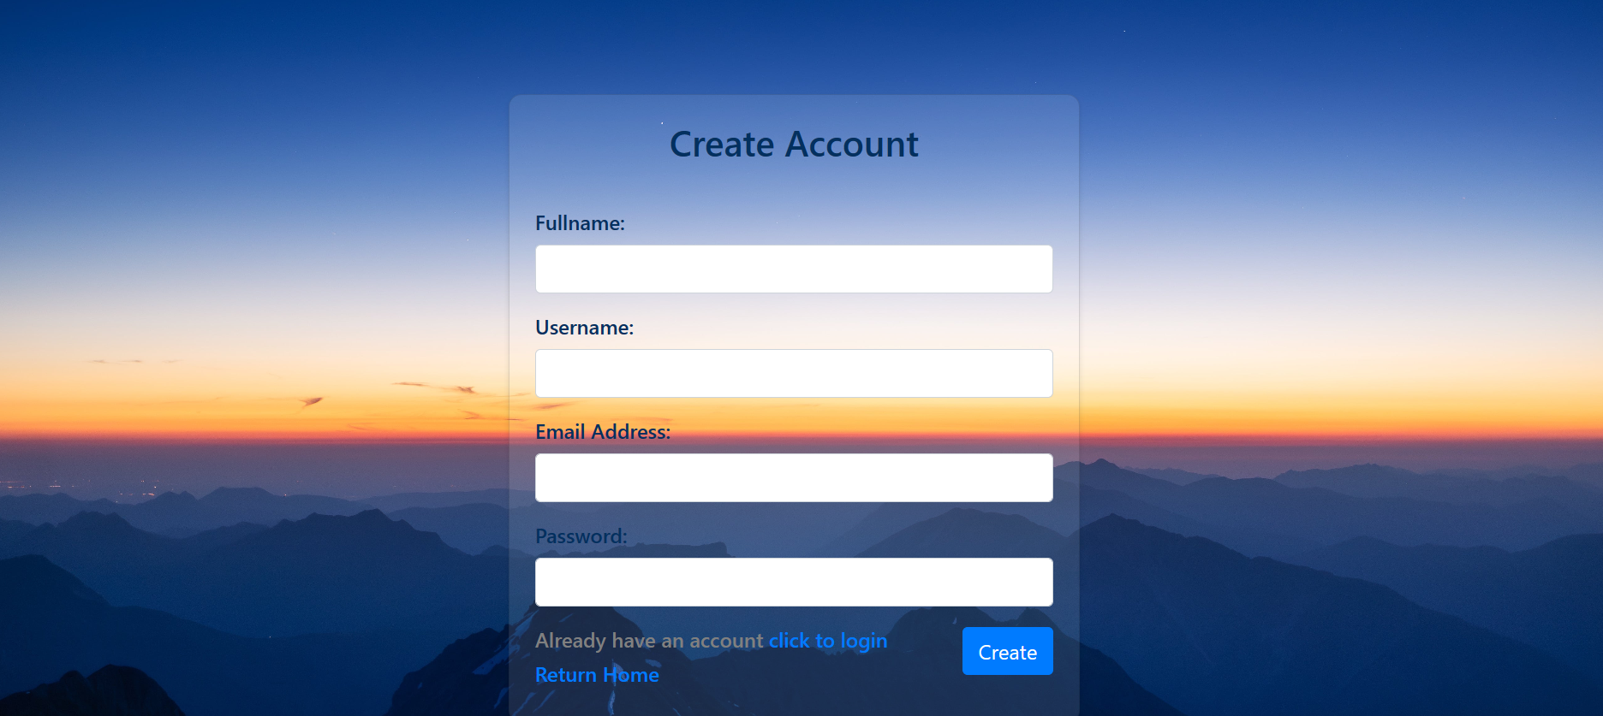

Figure Student sign up page.

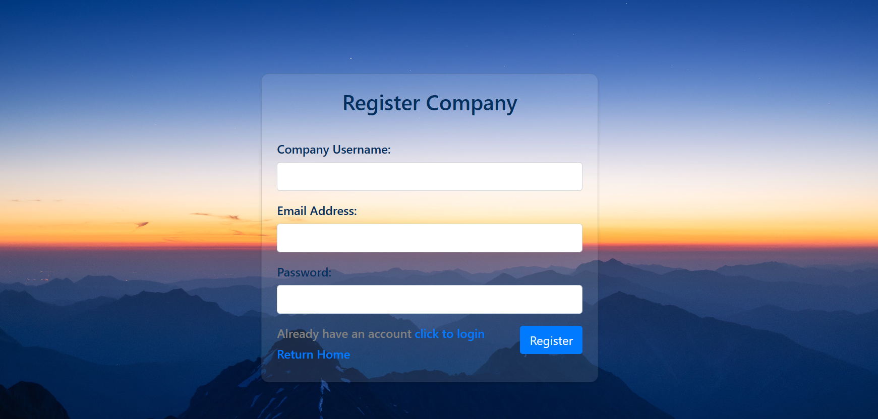

Figure Company sign up page.

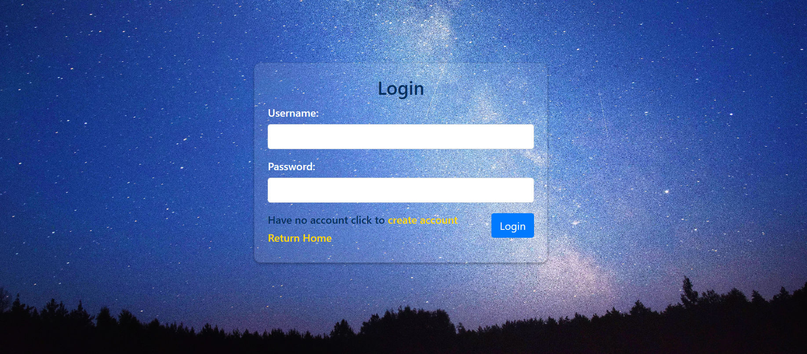

Figure User login page

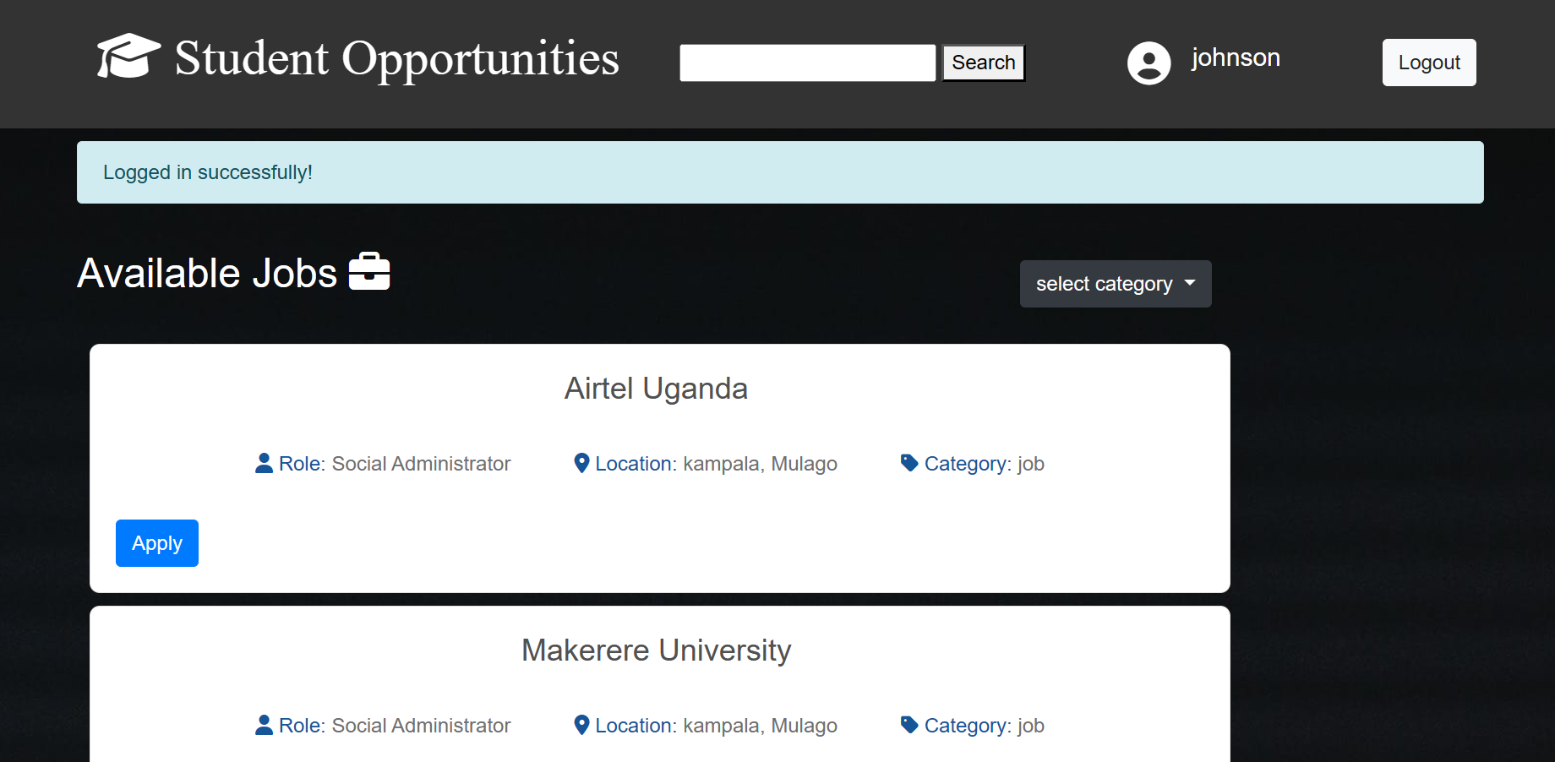

Figure Opportunities page seen by students.

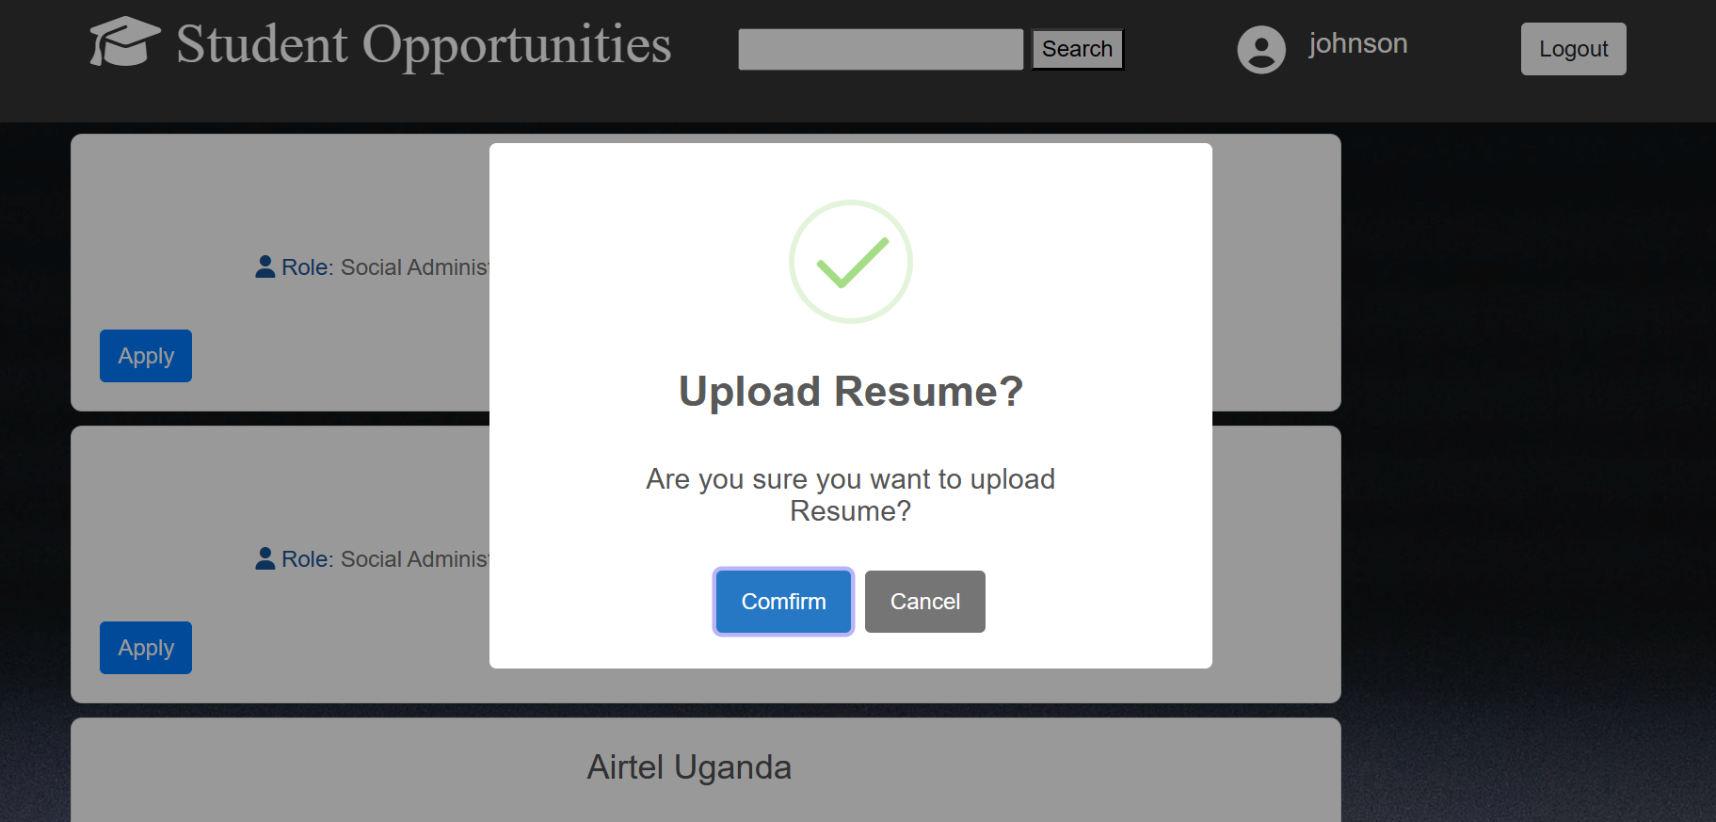

Figure Pop up on successful application.

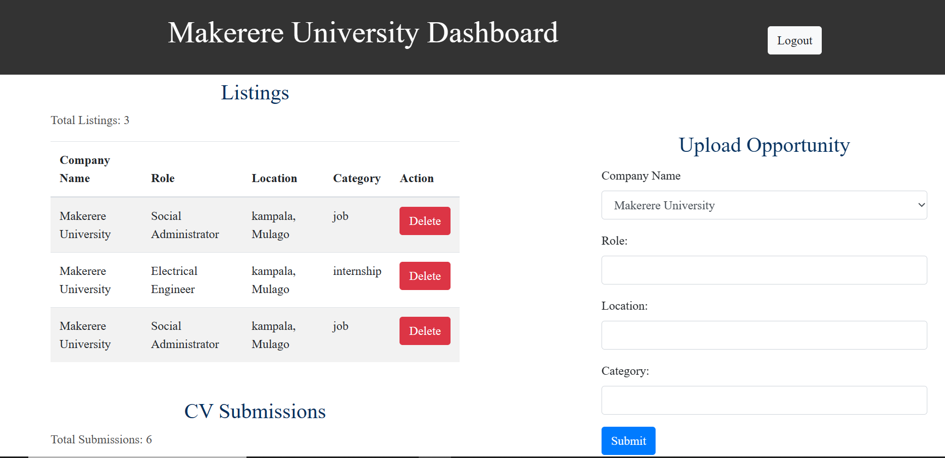

Figure Company dashboard.

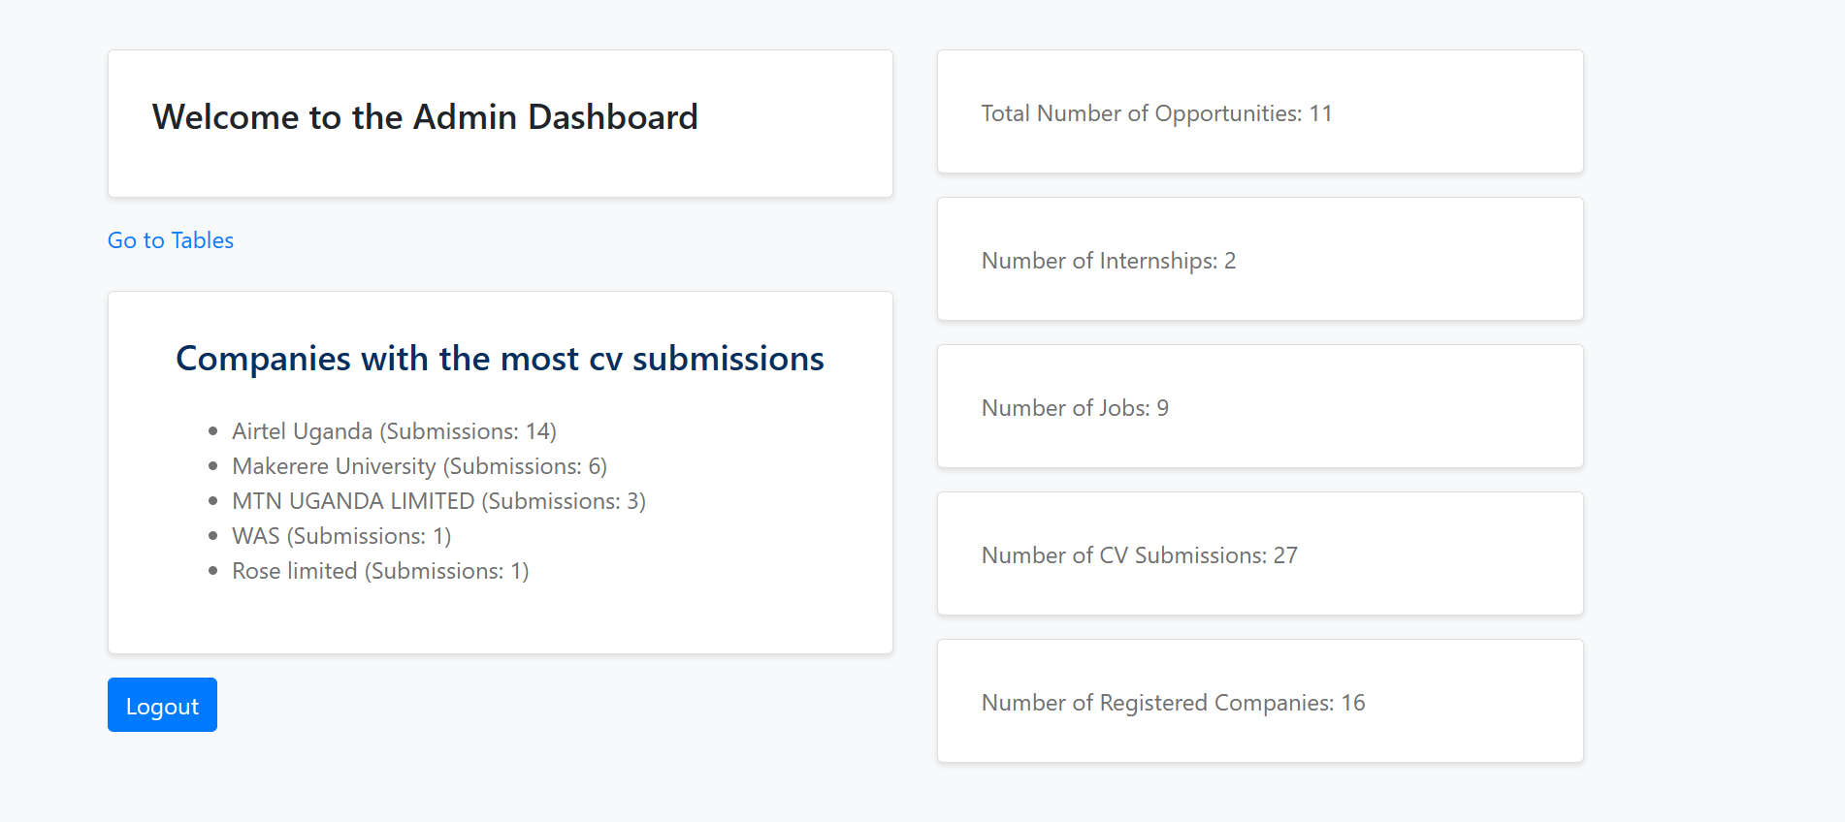

Figure Administrator dashboard

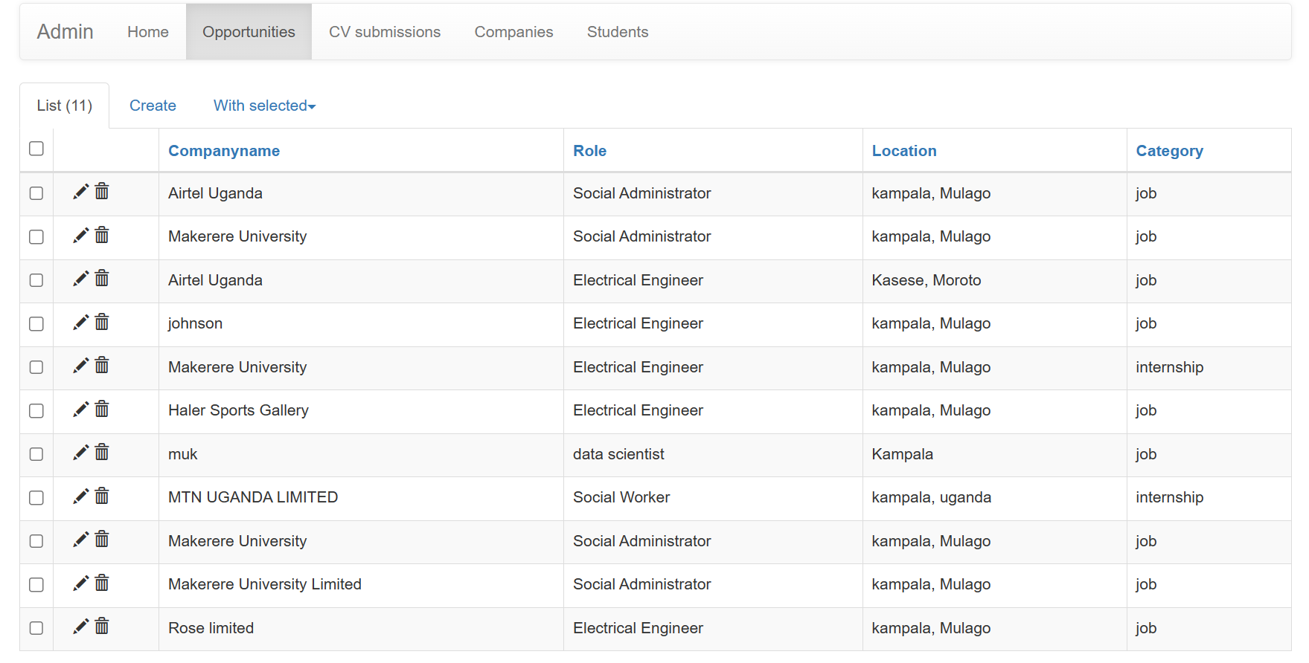

Figure User table seen by administrator.